Task Type: Extended Response
VALIDATION
Task 3: Lung Diseases and Treatments- Write a directed, comparative report on nominated lung diseases. Then complete an in-class validation assessment without research notes.

NAME:_ANSWERS
Answer the questions below about your research into Lung Diseases.

1. Write the names of the diseases you have researched here: Disease A_______________________________
Disease B_______________________________
a. Label the parts 2 to 7 in the diagram of the lungs in a human chest below. (6 marks)
b. Indicate the main area of the lungs each disease you researched affected, by circling the numbered label on the diagram and writing the disease name alongside. (2 marks)
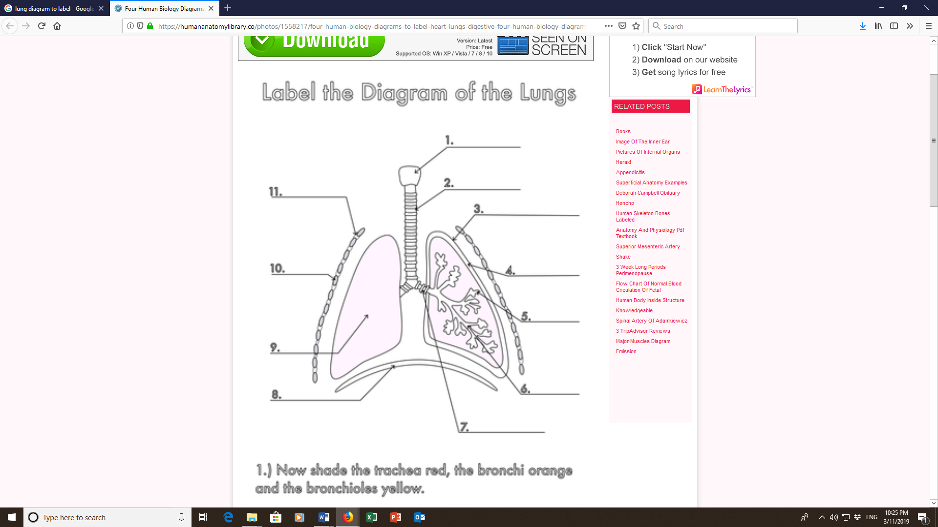
2. Trachea
3. Pleura/pleural membrane
5. alveoli
6. bronchioles
7. bronchi/bronchus
8. Diaphragm

2. Describe two main causes of each lung disease you researched.
Disease A. __________________________________________________________________________________________________________________________________________________________________________________________________________________________________________________________________________________________________________________________________________________________________________________________________________________________________________________________________________________________________________________________________________________________________________________________
Disease B ___________________________________________________________________________________________________________________________________________________________________________________________________________________________________________________________________________________________________________________________________________________________________________________________________________________________________________________________________________________________
(6 marks)

3. Various techniques are used to diagnose lung diseases. ( 6 Marks)
Choose from the list below, for each disease, one technique, or add in your own technique, and describe how the diagnostic technique is applied to the disease (how it works), and, what results will help to diagnose each disease.

X-ray | spirometer | Figure out disease timeline
Sputum culture | Physical examination | biopsy
Check out how well your lungs work | Sample of fluid –to test | Doctor’s exam –listening to chest
Screen new born babies | Test blood and sweat | Genetic testing
_________________________________________________________________________________________________________________________________________________________________________________________________________________________________________________________________________________________________________________________________________________________________________________________________________________________________________________________________________________________________________________________________________________________________________________________________________________________________________________________________________________________
________________________________________________________________________________________________________________________________________________________________________________________________________________________________________________________________________________________________________________________________________________________________________________________________________________________________________________________________________________________________________________________________________________________________________________________________________________________________________________________________________________________________________________________________________________________________________________________

4. Describe and explain 2 symptoms a sufferer of the diseases you researched may experience – choose from the ones in the table below, or add in your own list of symptoms. (8 marks)
Severe chest pain that goes away when you hold your breath | Cough with yellow/green/bloody mucus/chronic productive cough | Sharp pain in chest, often on one side only
Shortness of breath | Fever | chills
Pleural friction rub –from doctors exam. | Nagging cough | Chest pain
Wheezing | Salty tasting skin | fatigue

Disease A

Disease B

5. Outline two of the common treatments for ONE of the diseases you researched, and explain how they work. – use the treatments listed in the table to help you. (5 marks)

Cough suppressant/syrup | antibiotics | humidifier
Pain reliever | bronchodilator | Rest and fluids
Antiviral medication | Lifestyle changes | steroids
Needles/shot/vaccination | Physio | Mucolytics/mucus thinning drugs
exercise | well-balanced, high-calorie, high-protein diet. | Gene therapy

Which disease? __________________________________
______________________________________________________________________________________________________________________________________________________________________________________________________________________________________________________________________________________________________________________________________________________________________________________________________________________________________________________________________________________________________________________________________________________________________________________________________________________________________________________________________________________________________________________________________________________________________________________________________________________________________________________________________________________________________________________________________________________________________________
6. “Smoking, infections, and genetics are responsible for most lung diseases” is a quote from a medical reference source for lung disease. (5 marks)
a. Give evidence from your research which supports this contention.
_______________________________________________________________________________________________________________________________________________________________________________________________________________________________________________________________________________________________________________________________________________________________________________________________________________________________________________________________________________________________________________________________________________________________________________________________________________________________________________________________________________________________________________________________________________________________________________________________________________________________________________________________________________________

b. Referencing at least two of the three things mentioned in the quote, explain what can be done in terms of prevention of the lung disease, or reducing the severity of the condition. (6 marks)
__________________________________________________________________________________________________________________________________________________________________________________________________________________________________________________________________________________________________________________________________________________________________________________________________________________________________________________________________________________________________________________________________________________________________________________________________________________________________________________________________________________________________________________________________________________________________________________________________________________________________________________________________________________________________________________________________________________________________________________________________________________________________________________________________________________________________________________________________________________________________________________________________________________________________________________________________________________________________________________________________________________________________________

